***THE SUPERIOR UNIVERSITY***

**COMPUTER NETWORKINGS**

**LAB TASK 12**

**SUBMITTED TO**

**SIR RASIKH**

**SUBMITTED BY**

**NOOR-UL-AIN(172)**

**Section-(5D)**



***GOLD CAMPUS, 7 KM MAIN RAIWIND ROAD LAHORE***

**1. DHCP (Dynamic Host Configuration Protocol)**

**Definition:** DHCP is a network protocol used to automatically assign IP addresses and other network configuration parameters (like subnet mask, default gateway, and DNS servers) to devices on a network. This eliminates the need to manually configure each device.

**Example:**

* **Scenario:** In an office with 50 computers, a DHCP server assigns unique IP addresses dynamically.
* **How it works:**
  1. A device (e.g., PC or smartphone) sends a DHCP Discovery request when connecting to the network.
  2. The DHCP server responds with an IP address and network configurations.
  3. The device accepts the offer and joins the network.

**Benefit:** Saves time and reduces errors compared to manual IP configuration.

**2. VLAN (Virtual Local Area Network)**

**Definition:** A VLAN is a logical grouping of devices in a network, even if they are physically in different locations. VLANs segment network traffic to improve performance, security, and manageability.

**Example:**

* **Scenario:** In a hospital, there are three departments: Admin, Doctors, and Patients. Each department needs separate access to avoid interference.
* **How it works:**
  1. Devices in each department are grouped into separate VLANs (e.g., VLAN 10 for Admin, VLAN 20 for Doctors, VLAN 30 for Patients).
  2. Traffic within a VLAN is isolated, ensuring better performance and security.

**Benefit:** Efficient use of resources, improved security, and reduced broadcast traffic.

**3. DNS (Domain Name System)**

**Definition:** DNS translates human-readable domain names (like www.google.com) into IP addresses (like 142.250.190.78) that computers use to communicate.

**Example:**

* **Scenario:** A user types www.amazon.com into their browser.
* **How it works:**
  1. The browser sends a query to the DNS server to resolve the domain name.
  2. The DNS server responds with the IP address of Amazon's server.
  3. The browser connects to the IP address to load the website.

**Benefit:** Makes the internet user-friendly by allowing the use of names instead of hard-to-remember IP addresses.

**Summary Table**

| **Protocol** | **Purpose** | **Example Use Case** |
| --- | --- | --- |
| **DHCP** | Automatically assigns IPs | Office network assigning IPs to 50 devices without manual configuration. |
| **VLAN** | Segments network logically | Separate networks for Admin, Doctors, and Patients in a hospital. |
| **DNS** | Resolves domain names | Translating www.google.com to its IP address for accessing Google's web server. |

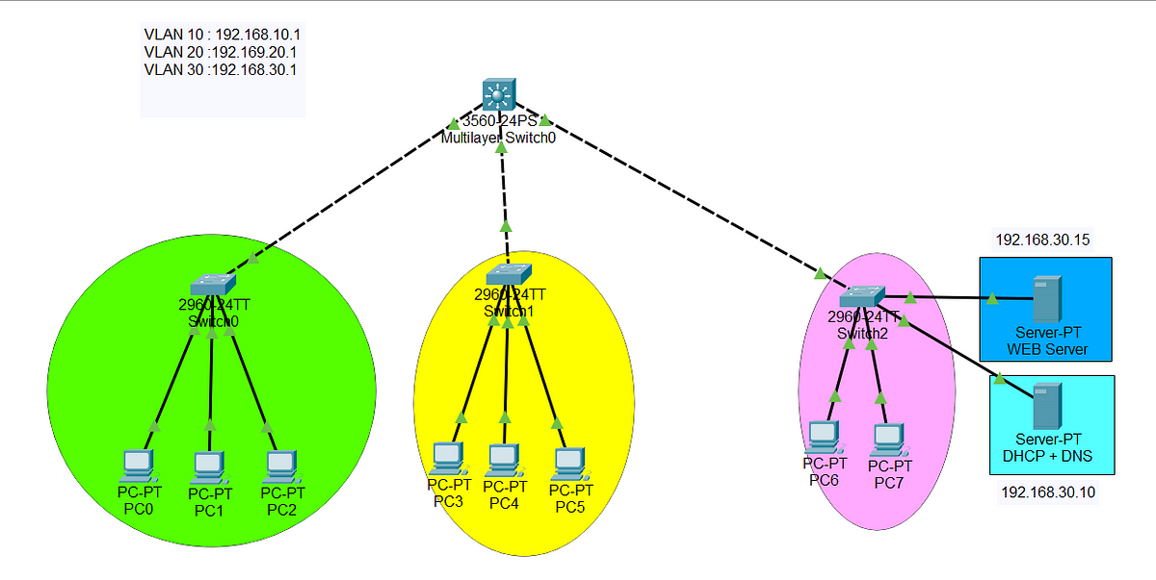These three technologies are vital for managing modern computer networks effectively.